DIS-AM,C-Mayan-Pre Classic

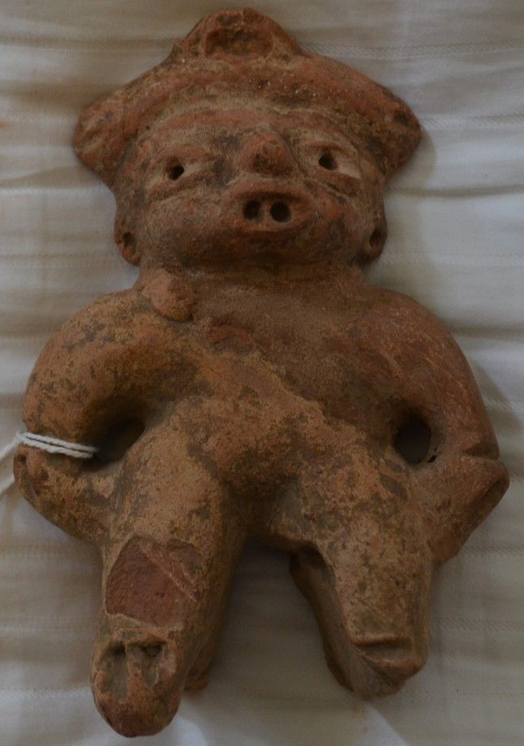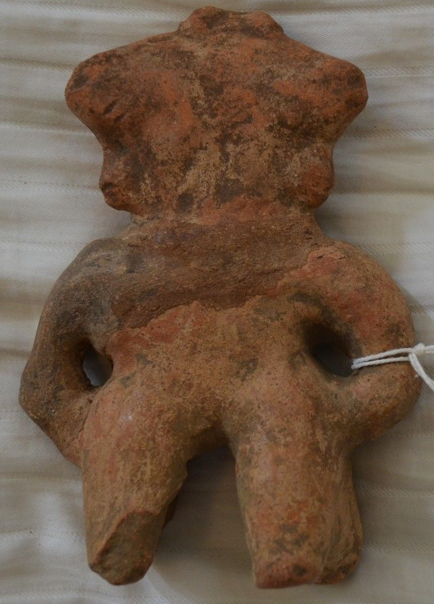

Pre-Classic Era Mayan figural sculpture 300 B.C - 300 A.D.

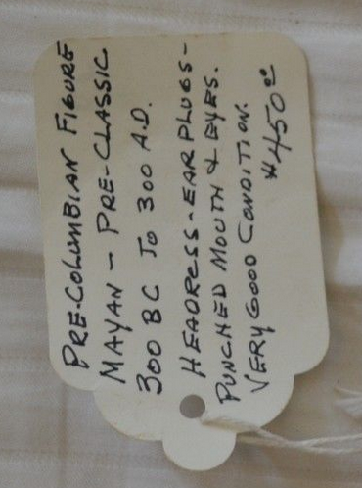

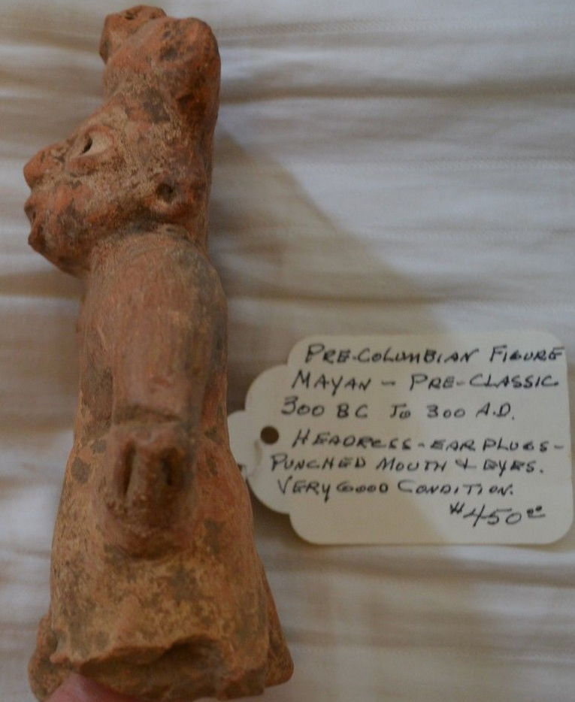 ?????

Figure has headdress, ear plugs and punched mouth and eyes.

Patches of white slip plaster still present.

Made for burial purposes, most likely from the Southern region of the Mayan Empire. Based on research and analysis, I can say with some authority that it was recovered from the Cihuatán - Aguilares (El Salvador) archaeological zone, then imported to the US most likely in the late seventies or early eighties.

5.5" tall x 3.75" wide.  
  
Authenticity determined by Clars Auction Gallery, Oakland, CA, March 2014. (AR-C-3-14)  Excellent condition, field repairs to neck and left arm/hand.

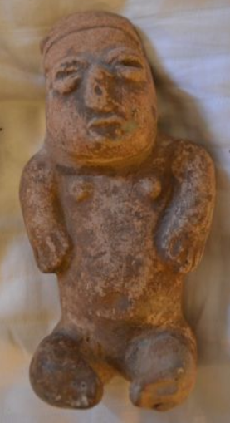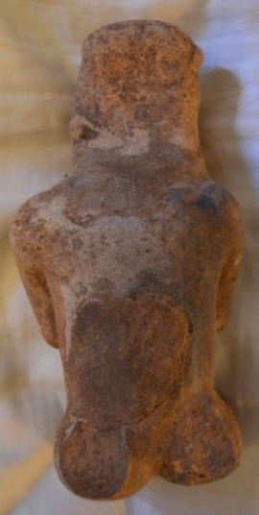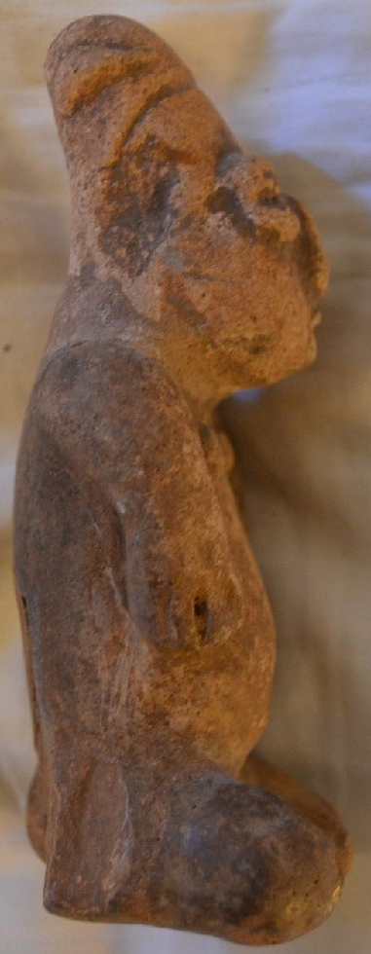

**Mayan seated figural sculpture 300 B.C. - 300 A.D.**

**Fertility theme, with headdress and interesting eye detail. Made for burial purposes.**

**Figure: 5.25" tall x 2.5" wide.**

**Provenance: Southern region of the Mayan Empire. Based on research and analysis, I can say with some authority that it was recovered from the Cihuatán - Aguilares (El Salvador) archaeological zone, then imported to the US most likely in the late seventies or early eighties.  
  
Authenticity determined by Clars Auction Gallery, Oakland, CA, March 2014. (AR-C-3-14)**

**Very Good condition. Field repairs to neck, lower back, and both legs.**